Project Report

Title : Simple Chatbot Using Python

1. Introduction :
A chatbot is a software application that simulates conversation with users through text or voice. Chatbots are widely used in customer support, virtual assistants, educational platforms, and information systems.
This project demonstrates the development of a Simple Rule-Based Chatbot using Python. The chatbot accepts text input from the user, recognizes keywords and patterns, and generates appropriate responses. It uses Python’s string processing techniques, conditional statements, and dictionaries to determine the most suitable reply. In this user will get different type of reply for the same input which makes it interesting.
Unlike AI-powered chatbots, this chatbot does not learn from conversations. Instead, it follows predefined rules and responds according to the keywords identified in the user’s message.

Functionalities
The chatbot can perform the following tasks:
- Recognize greetings (Hello, Hi, Hey)
- Respond to “How are you?”
- Introduce itself
- Tell the current time
- Respond to weather-related questions
- Tell a joke
- Display available commands using Help
- Respond to Thank You messages
- Handle Goodbye messages
- Perform basic small talk
- Handle empty inputs
- Handle unknown questions gracefully

2. Materials & Tools Used :
Component | Description
Programming Language | Python
IDE Used | Visual Studio Code
Operating System | Windows
Libraries Used | random, datetime
Project File | simple_chatbot.py

Library Description
random
- Used for selecting a random response from multiple predefined replies.
datetime
- Used to display the current system time whenever requested by the user.

3. Methodology :

Step 1: Program Starts
The chatbot welcomes the user and displays a greeting message.
The first line that will be print is :
“------------------------WELCOME TO THE PYTHON CHATBOT ---------------------------------"
↓

Step 2: User Enters Input
The program continuously waits for user name input using:
input("Enter your good name : ")
Then it will print for user :
print(f"ChatBot: Hello {name}! Type 'help' to see what I can do. OR Type 'bye' to EXIT. ")
Then it will wait for user input by printing user name:
user_input = input(f"{name} : ")
↓

Step 3: Input Processing
The entered text is converted into lowercase using
user_input.lower()
This allows the chatbot to recognize words regardless of capitalization.
Example
HELLO
↓
hello
↓

Step 4: Pattern Recognition
The chatbot searches for predefined keywords using conditionals such as
- greeting words
- weather
- help
- joke
- bye
- thanks
Example
If user enters
Hello
The chatbot detects the keyword hello and identifies it as a greeting.
↓

Step 5: Response Generation
After recognizing the user’s intent, the chatbot selects a suitable response.
Example
User: Hello
Possible chatbot responses
- Hello! How can I help you today?
- Hi there!
- Hey! Nice to meet you!
Random responses make the conversation more natural.
↓

Step 6: Continue Conversation
The chatbot keeps asking for new input until the user types
- bye
- exit
- quit
At that point, the program terminates.

4. Problem-Solving Approach :

A. Handling Empty Input
If the user simply presses Enter or enters only spaces,
the chatbot displays
Please type something so I can respond.
This prevents invalid processing.

B. Handling Unknown Questions
If the chatbot cannot identify any keyword, it replies with a default message such as
"Sorry {name} !, I am not able to answer these question. Please type 'HELP' in which you get the type of questions that I can answer easily. ThankYou {name}"

This ensures the chatbot never crashes due to unexpected input.

C. Case Insensitivity
All user input is converted to lowercase before processing.
Example: Hello, hello, HeLLo, All are treated as hello

D. Multiple Responses
Instead of displaying the same sentence every time,
the chatbot randomly chooses one response from a list.
This makes the chatbot appear more interactive.

E. Future Expansion
The chatbot can easily be expanded by adding:
- Mathematics solver
- Calculator
- College information
- FAQ system
- AI integration
- Voice recognition
- GUI using Tkinter
- Database connectivity
- Internet-based weather API
- Machine Learning capabilities

5. Flowchart :

START
│
▼
Display Welcome Message
│
▼
Take User name
|
▼
Take User Input
│
▼
Is Input Empty?
│ │
Yes No
│ │
▼ ▼
Show Warning Convert to Lowercase
│ │
└──────────►│
▼
Check Greeting?
│ │
Yes No
│ │
▼ ▼
Display Greeting Check Weather?
│ │
Yes No
│ │
▼ ▼
Display Weather Check Time?
│ │
Yes No
│ │
▼ ▼
Display Time Check Joke?
│ │
Yes No
│ │
▼ ▼
Tell Joke Check Help?
│ │
Yes No
│ │
▼ ▼
Display Help Check Bye?
│ │
Yes No
│ │
▼ ▼
Exit Unknown Input
│ │
▼ ▼
END Display Default Reply
│
▼
Ask Again

6. Testing & Results :
Test Case | User Input | Expected Output | Result
TC-01 | Hello | Greeting message | Pass
TC-02 | Hi | Greeting message | Pass
TC-03 | What is your name? | Bot introduces itself | Pass
TC-04 | How are you? | Bot responds with its status | Pass
TC-05 | Tell me a joke | Displays a random joke | Pass
TC-06 | What is the time? | Shows current system time | Pass
TC-07 | Weather today | Weather-related response | Pass
TC-08 | Thanks | You’re welcome message | Pass
TC-09 | Help | Displays available commands | Pass
TC-10 | Bye | Goodbye message and program exits | Pass
TC-11 | (Empty Input) | Requests user to enter text | Pass
TC-12 | asdfgh123 | Default “I don’t understand” response | Pass

Results :

Objectives Achieved -

Successfully handled user input and pattern recognition.

Implemented chatbot responses using conditionals and dictionaries.

Applied string processing for text-based interaction.

Developed a chatbot capable of handling more than 10 different user input types, including greetings, weather inquiries, time, jokes, and small talk.

Conclusion :
The Simple Rule-Based Chatbot demonstrates the fundamental concepts of chatbot development using Python. It successfully processes user input, recognizes predefined patterns, and generates appropriate responses using conditionals and dictionaries. The project provides a strong foundation for understanding conversational systems and can be further enhanced with graphical interfaces, databases, machine learning, and natural language processing techniques. This project serves as an excellent introduction to chatbot development and practical Python programming.

PYHTON CODE

# A simple rule-based chatbot using Python dictionaries, conditionals, and string processing
import random
from datetime import datetime
print("---------------------------------WELCOME TO THE PYTHON CHATBOT----------------------------------------")
print("")
print("*" * 100)
name = input("Enter your good name : ")
#Defined Responses in Dictionary
Responses = {
"greetings":["Hello! How can i help you Today",
"Hi there! What can i do for You?",
"hey! nice to chat with you."],
"how_are_you":["I'm doing great! Thanks for asking.",
"I'm fine and ready to chat",
"All good here. How about you?"],
"farewell":["See You Later",
"Bye! Take Care."
"GoodBye! have a great day!",
"Thanks for chatting"],
"thanks":["You're welcome!",
"No problem !",
"Happy to Help",
"Mention Not"],
"weather":["I can't check live weather right now, but I hope it's nice outside!",
"Weather chat is my thing, but I don't have live internet access here.",
"I cannot fetch real-time weather, but you can ask me about weather in general."],
"name": [
"I am SimpleChatBot, your Python assistant.",
"People call me SimpleChatBot.",
"I'm a basic chatbot created in Python."],
"help": [
"You can say hello, ask my name, ask the time, ask about weather, say thanks, or type bye to exit.",
"Try inputs like: hello, who are you, time, weather, help, joke, how are you, or bye."
],
"joke": [
"Why did the computer get cold? Because it left its Windows open!",
"Why do programmers prefer dark mode? Because light attracts bugs!",
"Why was the Python code so calm? Because it knew how to handle exceptions."
],
"mood": [
"I'm feeling productive!",
"I'm feeling helpful today!",
"I'm in a good mood to chat."
],
"small_talk": [
"That's interesting!",
"Tell me more.",
"Hmm, I see.",
"Okay, let's talk more about it."]
}
def bot_response(user_input):
user_input = user_input.lower().strip()
greetings = ["hello","hi","hey","good morning","good evening","good afternoon"]
if any(word in user_input for word in greetings):
return random.choice(Responses["greetings"])
farewells = ["bye", "goodbye", "see you", "exit", "quit"]
if any(word in user_input for word in farewells):
return random.choice(Responses["farewell"])
thanks_words = ["thank you", "thanks", "thx", "thanku","thankyou"]
if any(word in user_input for word in thanks_words):
return random.choice(Responses["thanks"])
name_words = ["your name", "who are you", "what is your name", "tell me your name"]
if any(word in user_input for word in name_words):
return random.choice(Responses["name"])
weather_words = ["weather", "rain", "sunny", "cloudy", "temperature", "forecast"]
if any(word in user_input for word in weather_words):
return random.choice(Responses["weather"])
time_words = ["time", "current time", "what time"]
if any(word in user_input for word in time_words):
current_time = datetime.now().strftime("%I:%M %p")
return f"The current time is {current_time}."
how_are_you_words = ["how are you", "how r you", "how are u", "how do you do"]
if any(word in user_input for word in how_are_you_words):
return random.choice(Responses["how_are_you"])
help_words = ["help", "what can you do", "commands", "options"]
if any(word in user_input for word in help_words):
return random.choice(Responses["help"])
joke_words = ["joke", "funny", "make me laugh"]
if any(word in user_input for word in joke_words):
return random.choice(Responses["joke"])
mood_words = ["how is your mood", "mood", "feeling", "are you happy"]
if any(word in user_input for word in mood_words):
return random.choice(Responses["mood"])
small_talk_words = ["okay", "cool", "nice", "hmm", "wow", "huh"]
if any(word in user_input for word in small_talk_words):
return random.choice(Responses["small_talk"])
return f"Sorry {name} !, I am not able to answer these question. Please type 'HELP'."
def main():
print(f"ChatBot: Hello {name}! Type 'help' to see what I can do. OR Type 'bye' to EXIT. ")
while True:
user_input = input(f"{name} : ")
if not user_input.lower():
print("ChatBot : Please type something so I can respond.")
continue
response = bot_response(user_input)
print("ChatBot: ", response)
if user_input.lower().strip() in ['bye','goodbye','exit','quit']:
print("------------------------------ThankYou for using the ChatBot-----------------------------------")
break
if __name__=="__main__":
main()
Screenshot of the ChatBot is Here :

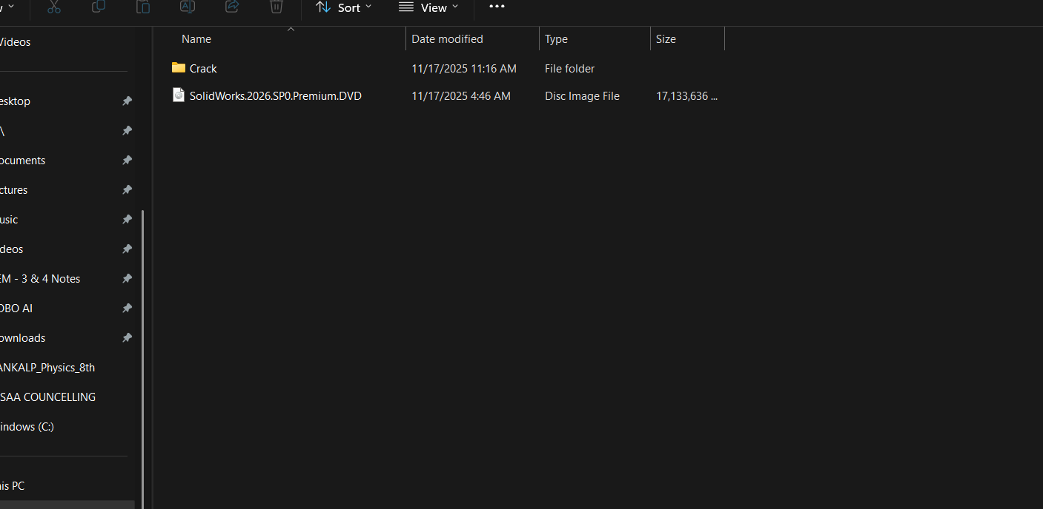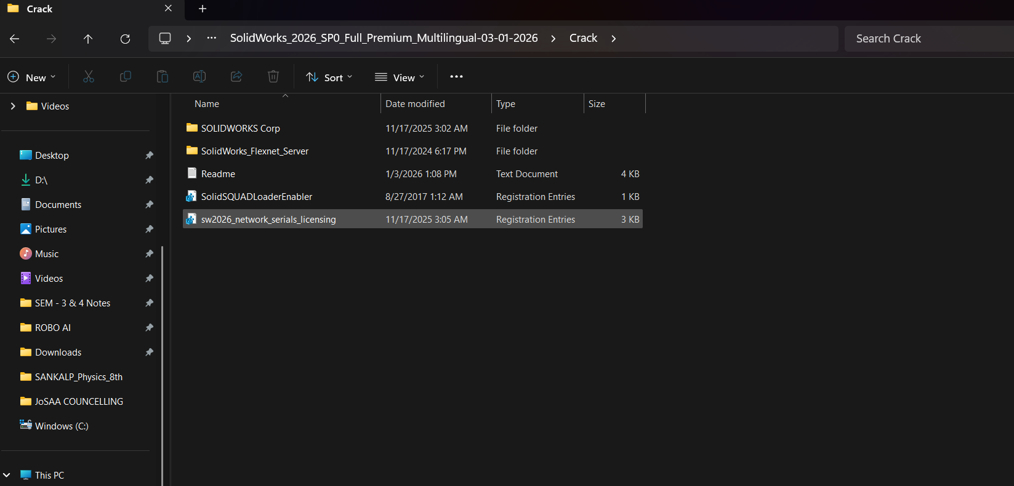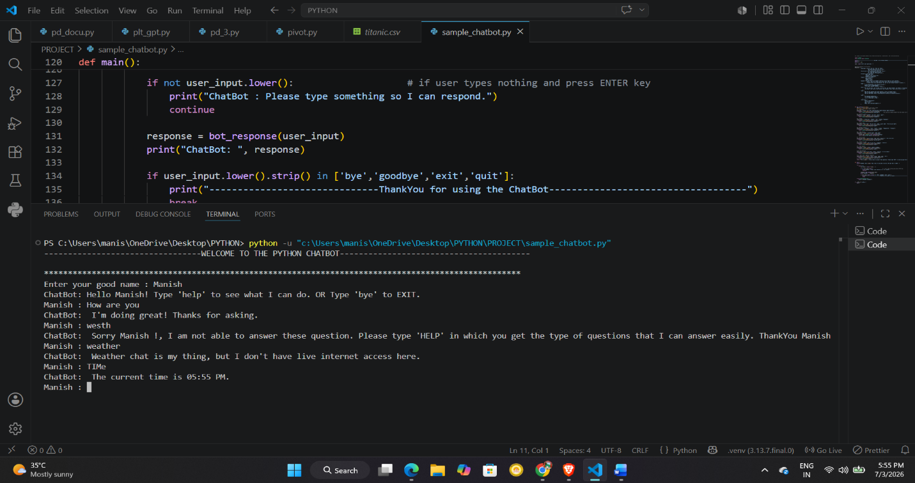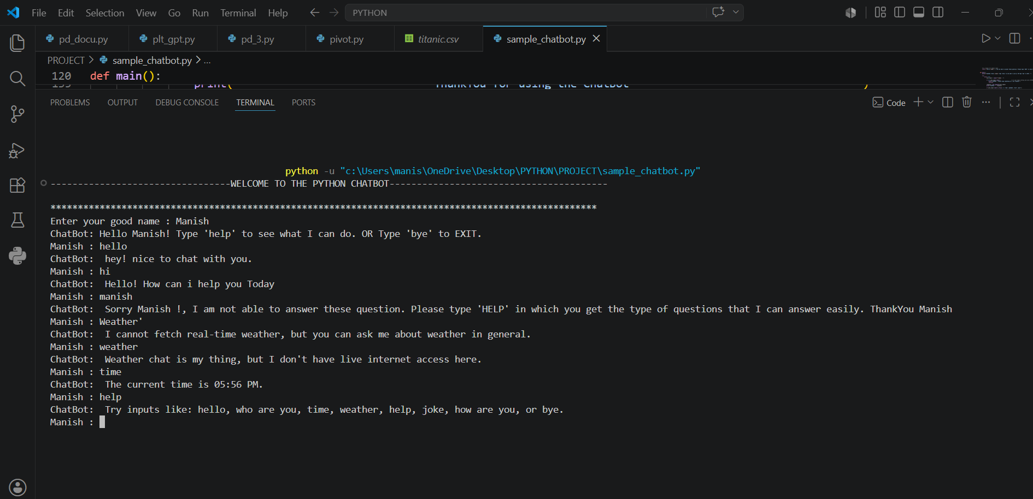

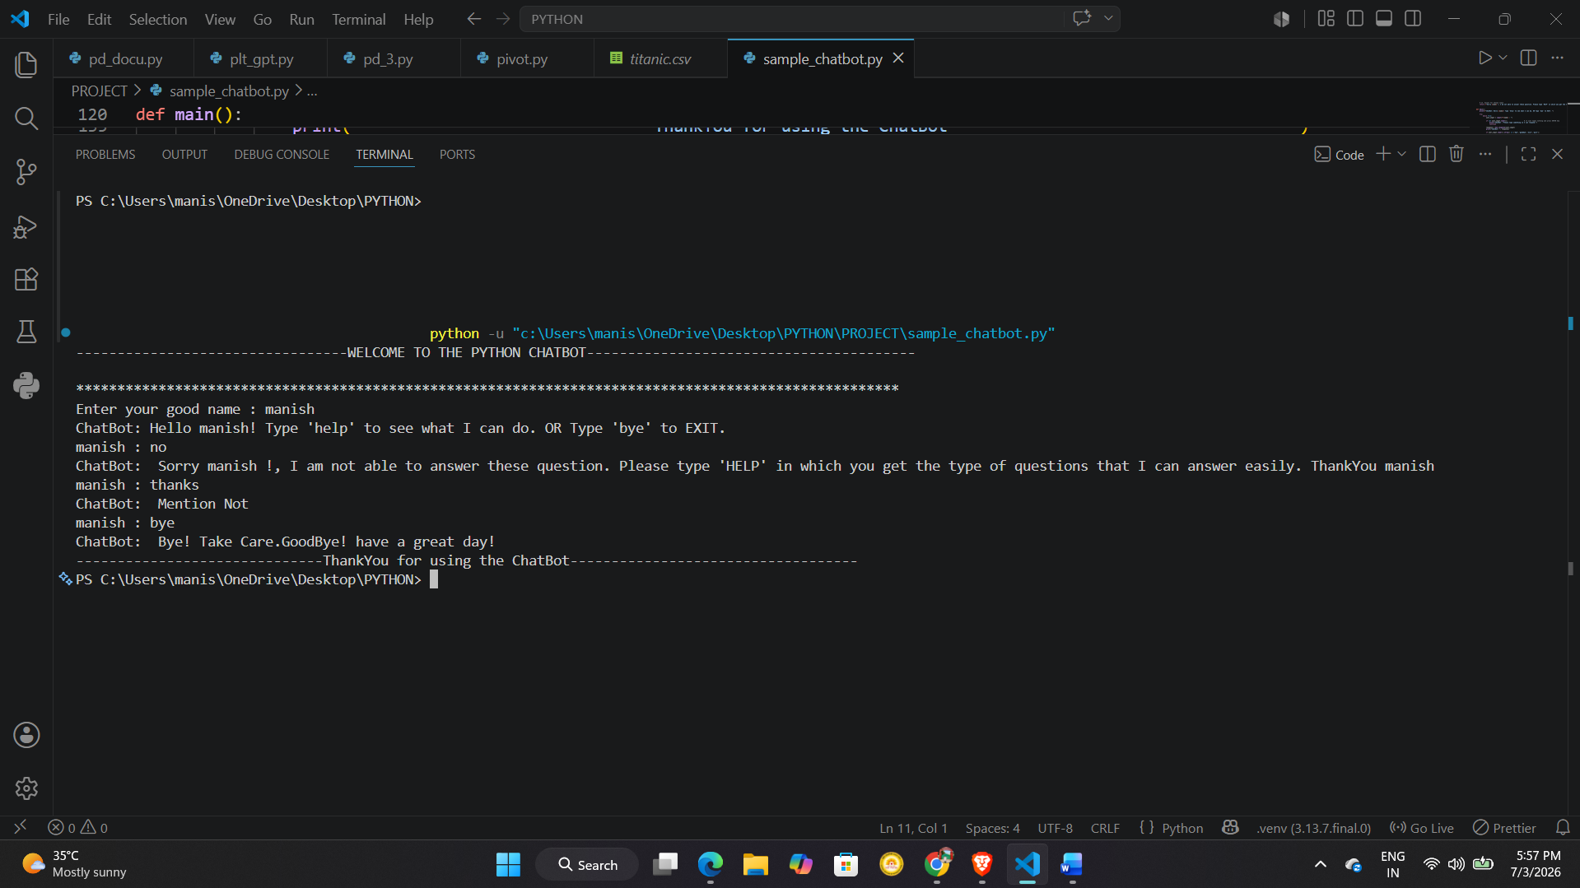
Sorry, I can’t upload the Video as I can upload only one file in the LMS so I have attached all the things in this document only.
Thankyou
Name : Manish Kumar
Batch : AI/ML
Mob : 8986061892
E-mail : manish.guptaa2006@gmail.com

